Fall Semester 2021-2022

Microprocessor and Interfacing

Lab Report

Digital Assignment-3

Experiment No: 4 Task No: 3

Course Code: CSE2006

Slot: L7+L8



Submitted By: Alokam Nikhitha

Reg. Numb: 19BCE2555

Submitted To: Dr. Abdul Majed KK

**EXPERIMENT 4:**

**Programs to find Factorial of a number**

**Aim:**

**1. Write an Assembly Language Programme (ALP) to find the factorial of a number 6.**

**2. Write an Assembly Language Programme (ALP) to find the factorial of a number 7.**

**Factorial of a number**

**Algorithm:**

**1) Move the value of whose factorial to be found in to the Accumulator.**

**2) Move the value in Accumulator to both Base Register and Counter Register.**

**3) Decrement both Base Register and Counter Register  
4) Multiply the Base Register to Accumulator and decrement the Base Register inside a loop**

**5) Loop is repeated and Base register is multiplied to Accumulator till the counter becomes 0.**

**6)The Factorial of the Given value is stored in Accumulator.**

**FLOW CHART**

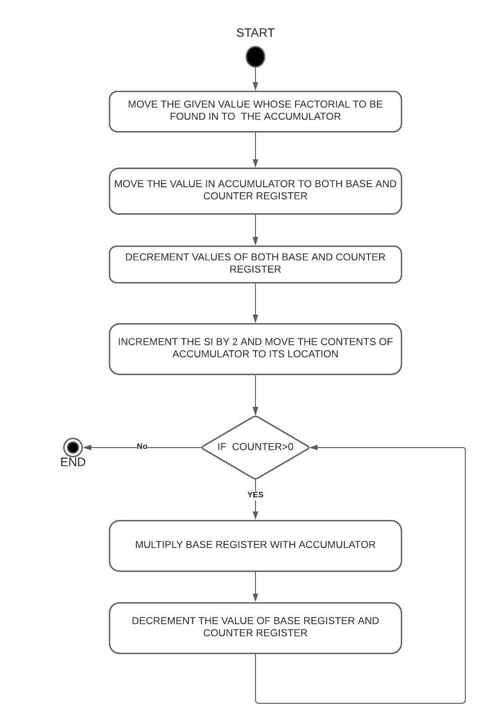

**1. Write an Assembly Language Programme (ALP) to find the factorial of a number 6.**

**Design and Calculations:**

**Here we input the value ‘6’ in to the accumulator and Move the value from Accumulator to Base Register and Counter Register and Decrement the value of both Base and Counter registers and run a loop and Multiply the Base register . And decrement the Base Register and loop is repeated until the counter becomes 0**

**Calculations:**

**6*5*4*3*2*1=2D0[Hex] (720[Dec])**

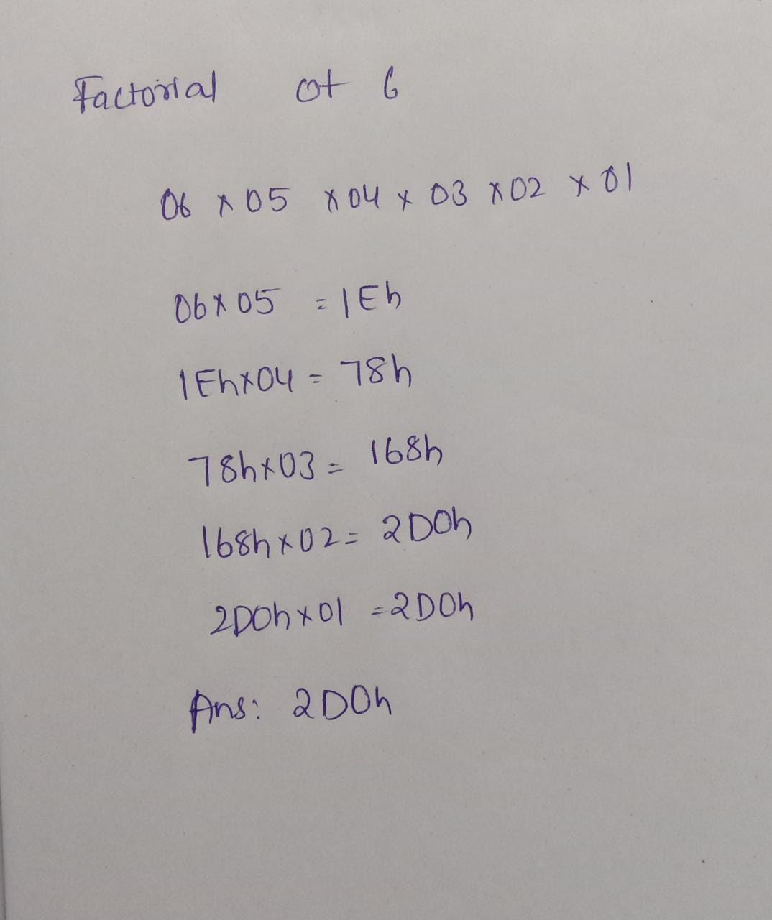

**Program Code:**

**Assume CS: Code DS: Data**

**DATA SEGMENT**

**ANS DW 0**

**DATA ENDS**

**CODE SEGMENT**

**START:**

**MOV AX, @DATA**

**MOV DS, AX**

**MOV AX, 6h**

**MOV CX, AX**

**DEC CX**

**MOV BX, AX**

**DEC BX**

**L:**

**MUL BX**

**DEC BX**

**LOOP L**

**MOV ANS, AX**

**CODE ENDS**

**END START**

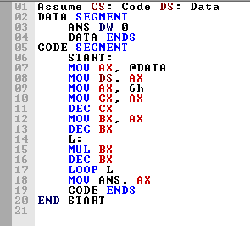

**Output:**

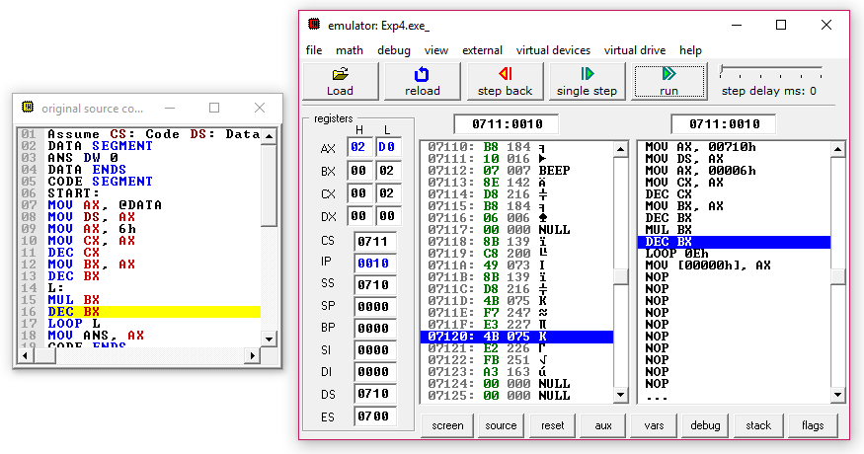

**Result and Inference:**

**-The Factorial of 6 (720[dec]-> 2D0[hex]) 2D0 is stored in Accumulator .**

**-Both Base and Counter Registers becomes 0.**

**2. Write an Assembly Language Programme (ALP) to find the factorial of a number 7.**

**Design and Calculations:**

**Here we input the value ‘7’ in to the accumulator and Move the value from Accumulator to Base Register and Counter Register and Decrement the value of both Base and Counter registers and run a loop and Multiply the Base register . And decrement the Base Register and loop is repeated until the counter becomes 0**

**Calculations:**

**7*6*5*4*3*2*1=13B0[Hex] (5040[Dec])**

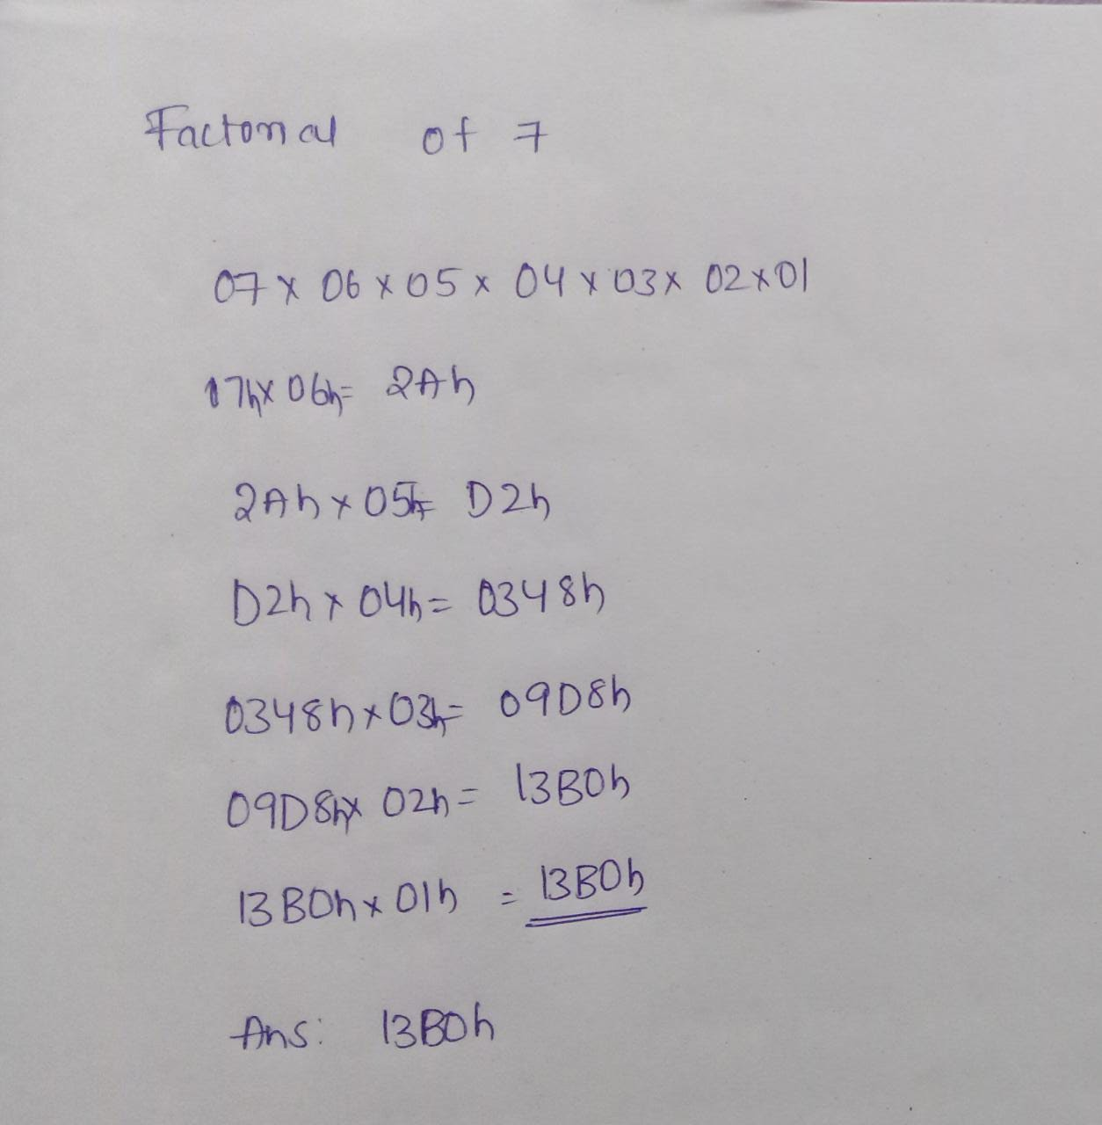

**Program Code:**

**Assume CS: Code DS: Data**

**DATA SEGMENT**

**ANS DW 0**

**DATA ENDS**

**CODE SEGMENT**

**START:**

**MOV AX, @DATA**

**MOV DS, AX**

**MOV AX, 7h**

**MOV CX, AX**

**DEC CX**

**MOV BX, AX**

**DEC BX**

**L:**

**MUL BX**

**DEC BX**

**LOOP L**

**MOV ANS, AX**

**CODE ENDS**

**END START**

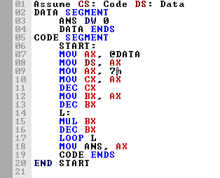

**OUTPUT:**

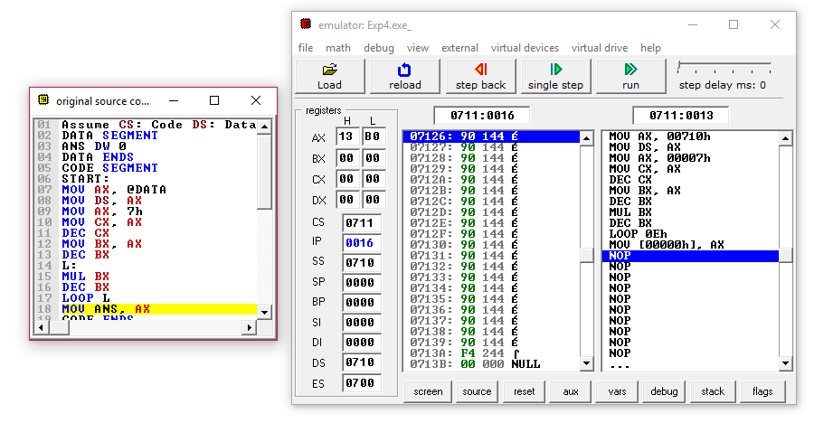

**Result and Inference:**

**-The Factorial of 7 (5040[dec]-> 13B0[hex]) 13B0 is stored in Accumulator .**

**-Both Base and Counter Registers becomes 0.**